**101413469 COMP 3133 ASSIGNMENT 1**

[**https://github.com/sahils777/comp3133_101413469_assignment1**](https://github.com/sahils777/comp3133_101413469_assignment1)

**MONGODB:**

**{show dbs**

**use comp3133_101413469_assignment1**

**show collections**

**db.users.find().pretty()**

**db.employees.find().pretty()}**

**Screenshots of API Tests in Postman:**

**Sign up:**

**Login:**

**Create/Add New Employee:**

**Get All Employees:**

**Search Employee by ID:**

**Search Employee by Designation/Department:**

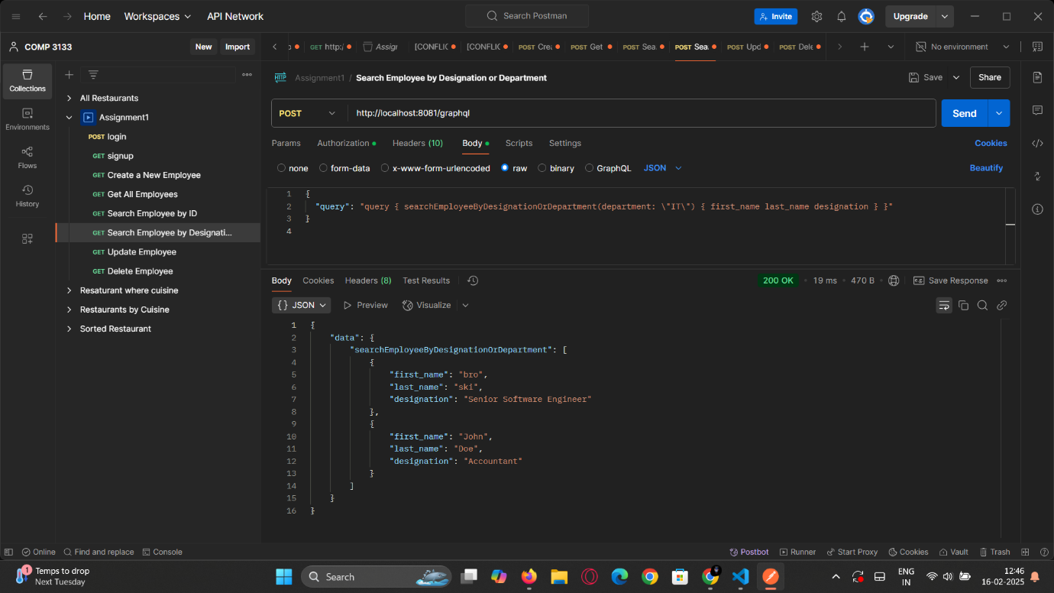

**Update Employee:**

**Delete Employee:**

